**EXP 1 : Write an assembly language program for adding two 8-bit data A7 A6 A5 A4 A3 A2 A1 A0 and B7 B6 B5 B4 B3 B2 B1 B0 using 8085 processor.**

**AIM:** To write an assembly language program to implement 8-bit addition using 8085 processor.

**ALGORITHM:**  
1)      Start the program by loading the first data into the accumulator.  
2)      Move the data to a register.  
3)      Get the second data and load it into the accumulator.  
4)      Add the two register contents.  
5)      Check for carry.  
6)      Store the value of sum and carry in the memory location.  
7)      Halt.

**PROGRAM:**  
LDA 8500   
MOV B, A   
LDA 8501   
ADD B   
STA 8502   
RST 1

**INPUT:**

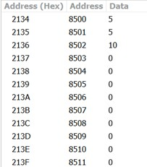

**OUTPUT:**

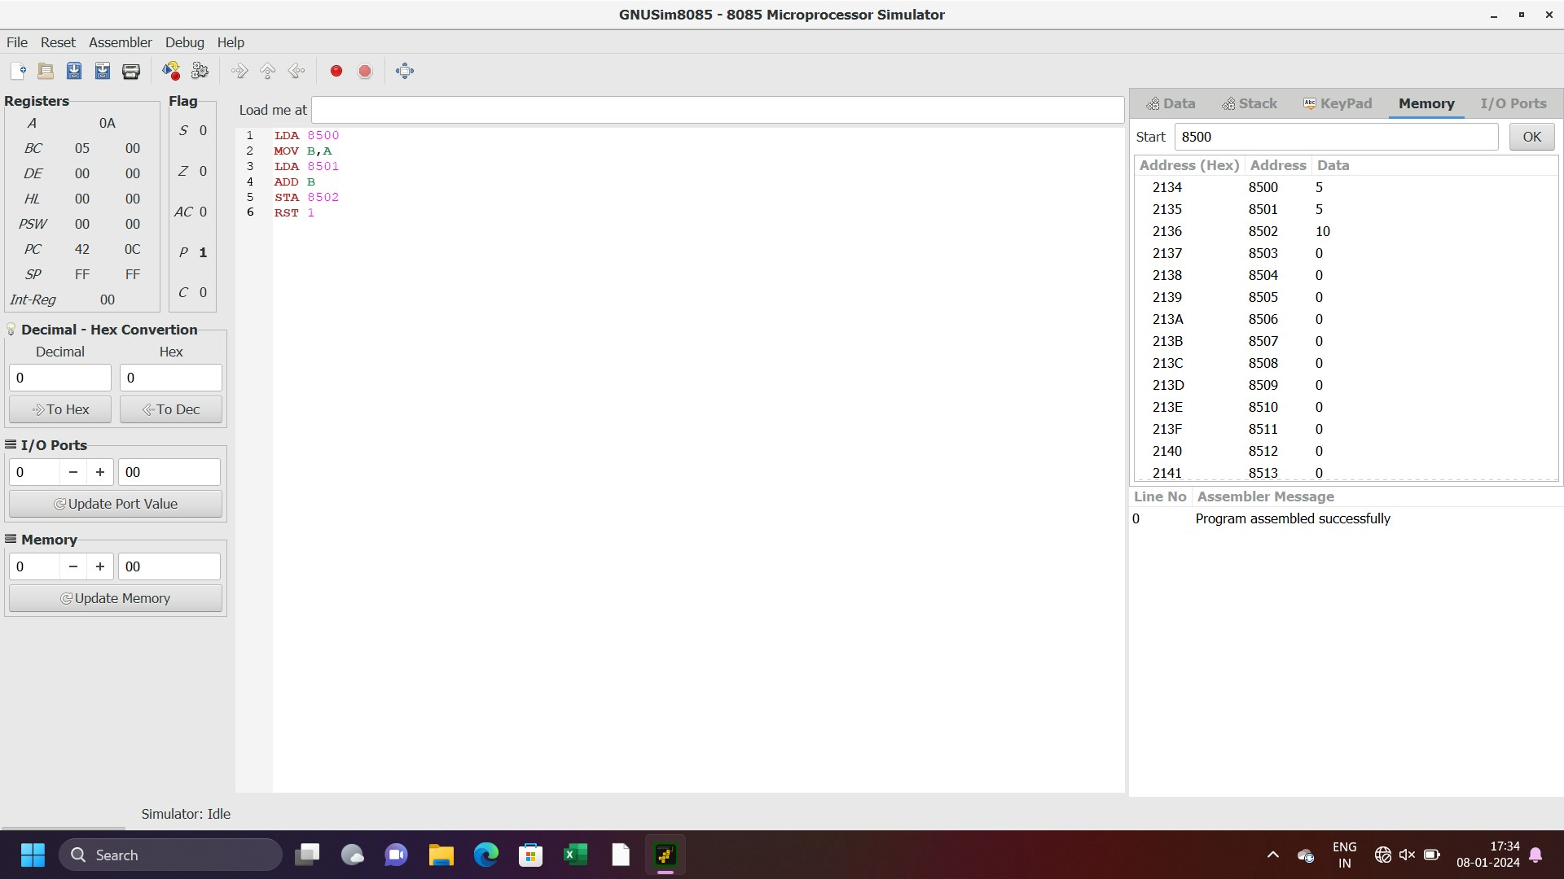  
   
  
  
   
  
  
   
  
  
   
  
  
  
  
  
  
  
  
  
  
**RESULT:** Thus the program was executed successfully using 8085 processor simulator.